TransCSR project: PESTO conference October 2nd - 3rd 2014
On the 2nd and 3rd of October, the “PESTO” conference took place in Graz (Austria) and the project TransCSR (Transparency of CSR skills through ECVET in European tourism) was presented by the lead applicant kate.
PESTO stands for Promotion and networking of EU projects on sustainable tourism. The conference had been organized by the network E.N.T.E.R, which aims at transferring and exploiting EU Project Results.

From more than 180 EU projects they had chosen and invited 20 EU-projects all related to the topic of sustainable tourism. Each project had a stand and presented promotional materials at the project fair. In addition to presentations the conference program offered a series of workshops. The workshop-session on qualification and training was attended by kate who had the chance to present the goals and contents of TransCSR.

PESTO- participants agreed on the necessity of integrating CSR in tourism SMEs but they underlined that most of them need assistance and training to able to implement the existing tools.

A video of the conference will be published soon on the project website: http://www.pesto-project.eu/

Background regarding the projects TransCSR and PESTO project


Started in October 2013 and ending in September 2015, the project TransCSR aims at the transparency and acknowledgement of CSR skills in the tourism sector of at least six European countries using the tools of the ECVET system (European Credit system for Vocational Education and Training) and the EQF (European Qualification Framework). The project is founded by the European Commission, DG Culture and Education. In September 2015, the project will deliver an e-learning tool on CSR skills for the self-evaluation, Learning Agreement as well as a Memorandum of Understanding which will be formulated for the establishment of the formal acknowledgment of CSR skills
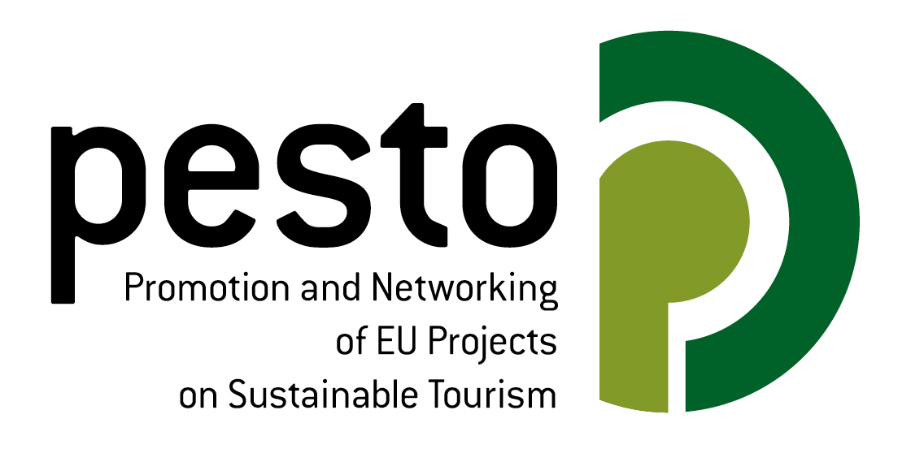
From the other side, the project PESTO aims to link EU projects and different funding programmes on sustainable tourism by developing networks and promotion platforms for project consortia, allowing them to learn from each other and providing them with special opportunities to directly interact with target groups, stakeholders and the public.

Read more about the projects:
TransCSR:
http://kate-stuttgart.org/de/ueber-kate/unsere-projekte/im-bereich-csr-und-csr-tourism/transcsr.html

PESTO:
http://www.pesto-project.eu/

